Hyperdrive Cosmetic Changes

Epic’s move to Hyperdrive is largely to improve access and background functionality, but it also makes some cosmetic changes.

User will notice these mostly when looking for data in the system as the various search functions were modified to be more functional and have fewer pop-up windows. Below are the most changes lab staff will likely encounter.

Epic Search Bar

Old: Ever present in Upper-Right corner of the screen
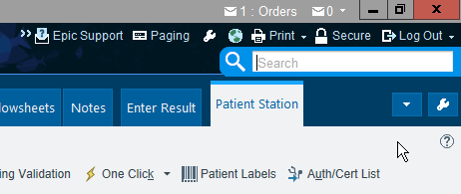

New: Under the Epic button

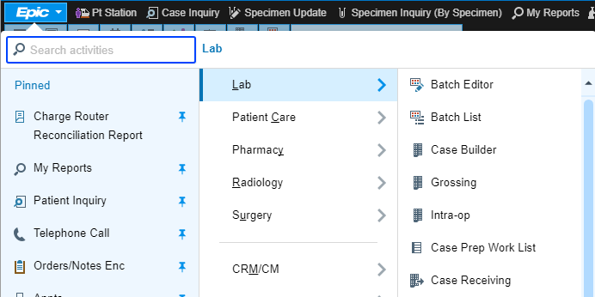

Searching for Specimens
Specimen Update/Specimen Inquiry/Case Inquiry/Case Builder

Old:
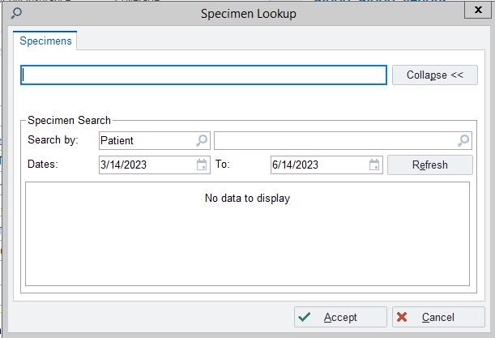

New: Condensed
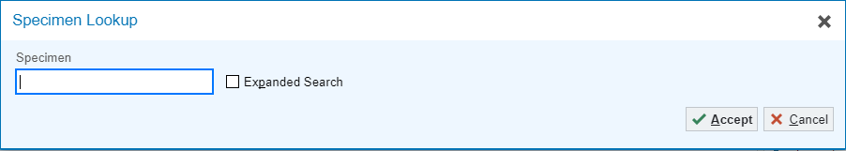

Expanded
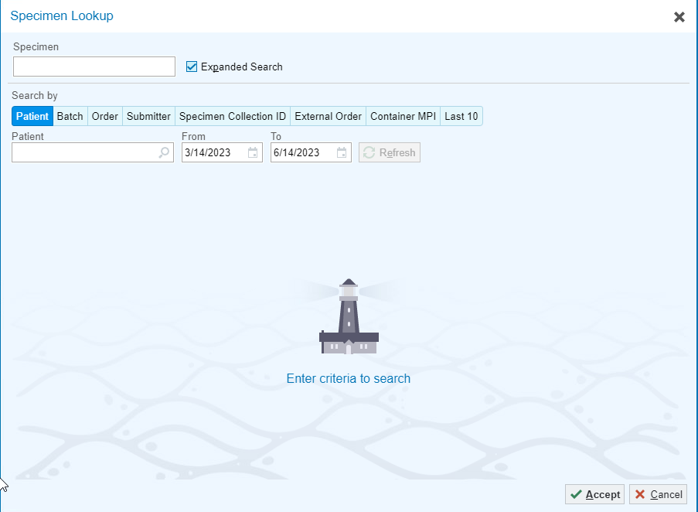

Note: AP searches open Case Lookup instead of Specimen Lookup but share the same layout

Patient Station: Changed from 2, to 1 step search

Old:
Search Box and Open Patients
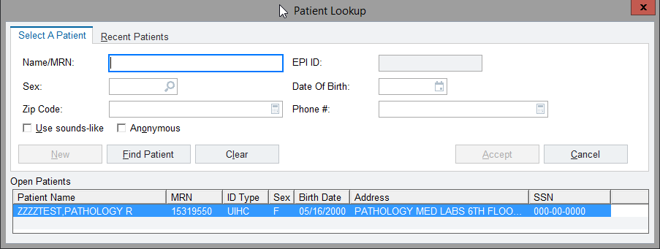
After Search, Results open in Separate Pop-Up

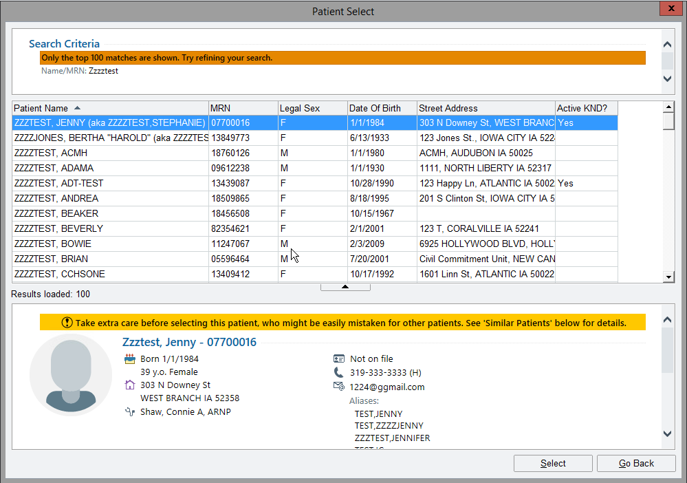

New:
Search Box and Open Patients
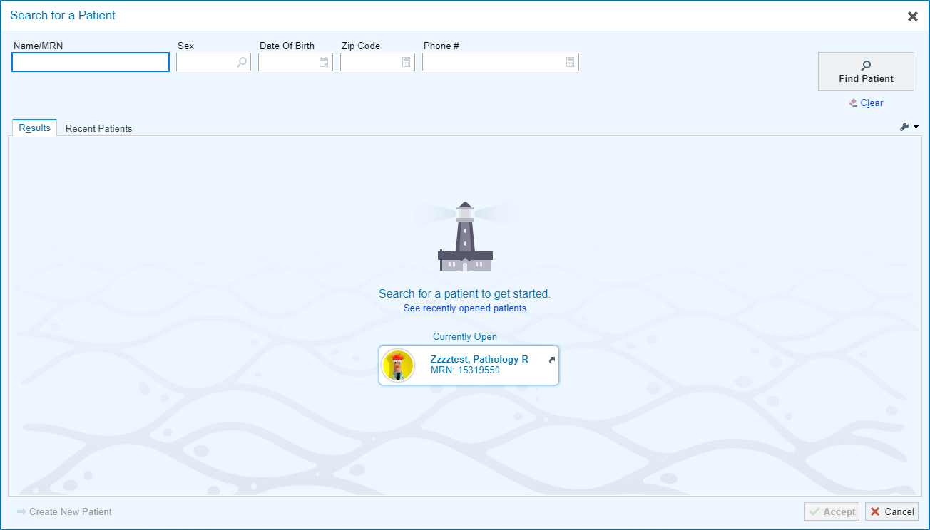
Search Results appear in the same box for ease when modifying search parameters

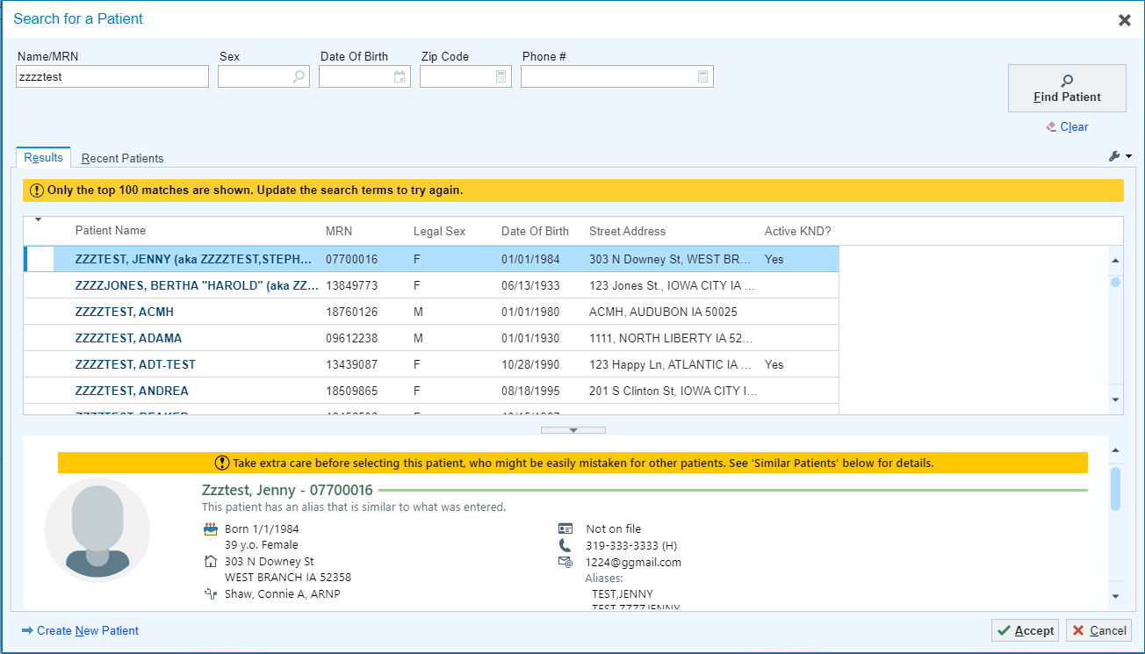

Packing List Editor: List Types are now in the same Pop-Up window
Old:Open Packing Lists and Create options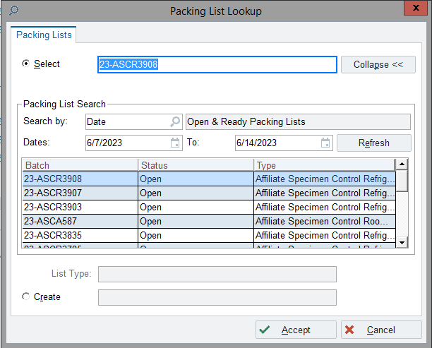
List Types open an new window when Creating a new Packing List
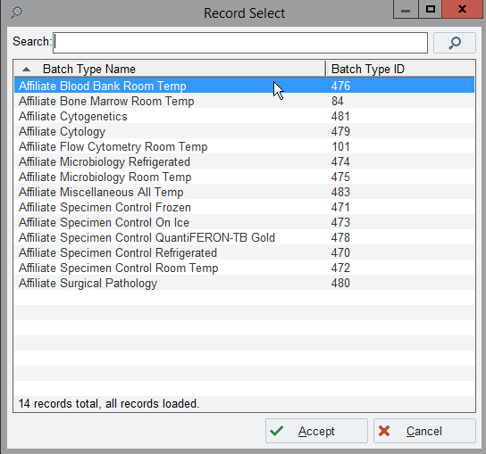

New: The Packing List Types are in same window
