SUBJECT/TITLE: | Operating a Gas Powered Pole Saw
PURPOSE: | Safe Operation of a Gas Powered Pole Saw.

Policy Statement:

The Engineering Services Department will provide proper training to staff that operate any Gas Powered Pole Saw.

Required PPE:
- Safety Shoes/ Boots with Reinforced Toe 5. Safety Googles or Face Shield
- Appropriate gloves 6. Chaps
- Hearing Protection, Ear Plugs or Muffs 7. Hard Hat
- Safety Vest 8. Dust Mask as needed

Required Training:

- Read, understand, and follow manufacturer’s safety instructions

- Training with qualified person prior to use

TASK | HAZARDS | CONTROLS
Preparing Saw | Hand Injuries | Wear leather (or other durable) gloves, use caution when handling blades.
Fueling/Oiling | Fire | Always add fuel outdoors, ensure fuel cap is secure before use.
Fueling/Oiling | Fire | Do not add fuel if near open flame or sparks.
Fueling/Oiling | Fire | Clean-up fuel spills immediately; do not start engine until fumes have dispersed.
 | Chemical Exposure: Skin or Eyes | Wear appropriate gloves and eye protection when fueling.
General Use | Bodily Injury | Wear all required PPE.  Use of cones or barricades to maintain safe work zone.
General Use | Bodily Injury | Keep all shields in place when not in use.
General Use | Bodily Injury | Keep hands, clothing, and hair clear of all moving parts.
General Use | Bodily Injury | When working overhead or under other workers, wear hard hat.
General Use | Inhalation of Dusts or Particles from Cutting | Wear dust mask as needed.
General Use | Eye Injury | Wear safety goggles or face shield to prevent eye/face injury from flying wood chips or vegetation, etc.
General Use | Hearing Damage | Wear hearing protection: ear plugs or earmuffs.
General Use | Foot Injury | Wear safety shoes or boots with reinforced toe.
 | Injury to Others | Use cones, barricades or other department staff members to keep others clear of area. Staff members may need to wear PPE.
General Use | Bodily Injury from Vehicles, Bicyclists, etc. | Place signs, cones, barricades, caution tape and lookouts as needed.
General Use | Bodily Injury from Vehicles, Bicyclists, etc. | Wear reflective safety vests.
Additional Precautions for Fuel Powered Engines | Injury and Fire | Always operate in well-ventilated area.
Additional Precautions for Fuel Powered Engines | Injury and Fire | Never fuel engine while running.
Additional Precautions for Fuel Powered Engines | Injury and Fire | Stop engine before performing maintenance or trouble shooting.
Procedure for Malfunctioning or Broken Equipment | Bodily Injury | Obtain tag from shop, mark equipment "Do Not Use"- Specify problem.
Procedure for Malfunctioning or Broken Equipment | Bodily Injury | Notify shop and/or take equipment to shop.

Training: Operating a Gas Powered Pole Saw

Training Video: https://www.youtube.com/watch?v=b3AD1dbNd78

DO NOT use this machine unless you have been trained in its safe use and operation. Training must be documented and signed by the employee before use.

Description of Work: |  |  | Operating A Gas Powered Pole Saw
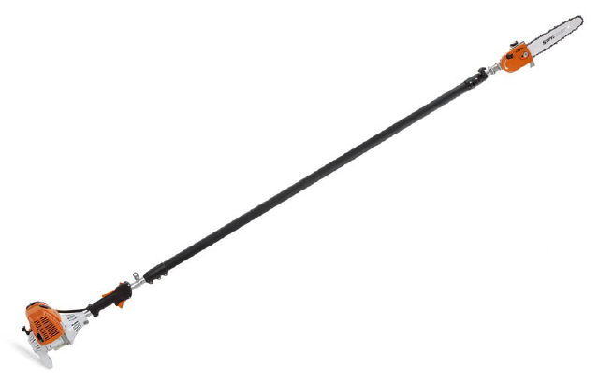 |  |  |  |  |  | Potential Hazards:  Potential to cause harm from chain, impact and abrasion, exhaust heat or crushing injuries, ergonomics, vibration, noise, slips, trips and falls and dust.
Personal Protective Equipment (PPE) Required
  Gloves |  |   Face Masks |  |   Eye  Protection |   Welding Mask |  |   Appropriate  Footwear |  |   Hearing Protection |   Protective Clothing
Safe Work Procedure Checklist:
1. PRE-Operation:
- Check for obvious faults and defects including fuel leaks or damage.
- Identify ON/OFF switch.
- Wear adequate and appropriate PPE.
2. Operation:
  - Exercise caution in relation to exhaust heat.
  - Hold firmly with both hands.
  - Ensure firm footing.
  - Move your body with the direction of work; do not twist from the waist.
  - Use trip hazard signs or cones when in operation.
  - Do not allow pedestrians to travel in work area.

3. POST-Operation:
- Ensure pole saw engine has stopped and cover is over chain.
- Ensure pole saw is clean from dirt and debris.
- Ensure equipment is returned to storage area after use and full of fuel and bar oil.
Competent Persons (The following persons are authorised to operate equipment.
Date: | Name: |  |  |  |  |  |  | Trainer Signature:

Source: UI Healthcare Engineering Services
Date effective: June 6, 2016
Date Reviewed:

