SUBJECT/TITLE: | Operating a John Deere Riding Mower
PURPOSE: | Safe Operation of John Deere Riding Mower.

Policy Statement:

The Engineering Services Department will provide proper training to staff that operate any John Deere Riding Mower.

Required PPE:
- Safety Glasses 4. Safety Shoes/ Boots with Reinforced Toe
- Dust Mask as needed 5. Hearing Protection, Ear Plugs, or Muffs
- High Visibility Vest as needed

Required Training:

- Read, understand, and follow manufacturer’s safety instructions

- Training with qualified person prior to use

TASK | HAZARDS | CONTROLS
Preparing Job Site And Equipment | Trips | Clear area within work zone; Remove trip hazards and/ or mark clearly hazards with cones, remove large branches, etc.
Preparing Job Site And Equipment | Cuts | Wear gloves when checking tires and attaching implements.
Preparing Job Site And Equipment | Exposure to Oil/Coolant | Wear safety glasses and gloves if adding any fluids.
Preparing Job Site And Equipment | Bodily Injury to Others | Identify work zone if needed use cones, barricades and other means necessary to keep pedestrian and other traffic out of the work zone.
Operational Considerations | Bodily Injury | Wear reflective safety vest when traveling on roadways.
Operational Considerations | Bodily Injury | A pre-job discussion should occur to ensure both the equipment operator and assisting workers understand the scope of the project when needed.
Operational Considerations | Bodily Injury | Operator should keep watch for ground workers near equipment and ensure they are aware of operator's intended direction of movement. Use spotter as need to warn/watch for ground workers.
Operational Considerations | Bodily Injury | Ground workers should watch operator and equipment, staying clear of equipment's path and mower discharge.
Operational Considerations | Bodily Injury | All workers need to be aware of changing conditions at work site area.
Equipment Operations | Falling Off Equipment | Ensure firm footing and use of handle grips as needed
Equipment Operations | Rollover | Do not turn sharply on hill sides at high speeds
Equipment Operations | Rollover | Do not load/unload riding tractor on uneven ground
Equipment Operations | Rollover | Operate within manufacturer listed stability speeds
Equipment Operations | Bodily Injury to Operator | Never reach into areas with moving parts such as tires, mower deck belts, PTO attachments.
Equipment Operations | Bodily Injury to Operator | Never leave equipment running to clear tires, debris from belts or troubleshoot problems
Equipment Operations | Bodily Injury to Operator | Do not operate damaged or malfunctioning equipment.
Equipment Operations | Bodily Injury to Operator | Be aware of changing conditions at worksite.  Always keep mower chute down while in operation
Equipment Operations | Bodily Injury to Operator | Be aware of fluid leaks.
After operations or during periods when area is not occupied by workers | Bodily Injury to Workers and Others | Operator should always leave equipment with PTO disengaged and turned off.
 | Bodily Injury to Workers and Others | Operator should ensure equipment is secured/locked out so cannot be used by unauthorized personnel.
 | Bodily Injury to Workers and Others | Workers should secure job site if needed with barricades, cones and signs to warn others to keep out of work site area.
 | Bodily Injury to Workers and Others | Supervisor may place employee to watch job site if extreme hazards exist.
Servicing or Repair of Equipment | Bodily Injury | Obtain tag from shop, mark equipment "Do Not Use"- Specify problem
Servicing or Repair of Equipment | Bodily Injury | Notify shop and/or take equipment to shop

Training: Operating A John Deere Riding Mower

Training Video: https://www.youtube.com/watch?v=wgJlz9NPUmg

https://www.youtube.com/watch?v=kBAPyBzKUDM

DO NOT use this machine unless you have been trained in its safe use and operation. Training must be documented and signed by the employee before use.

Description of Work: |  |  | Operating A John Deere Riding Mower
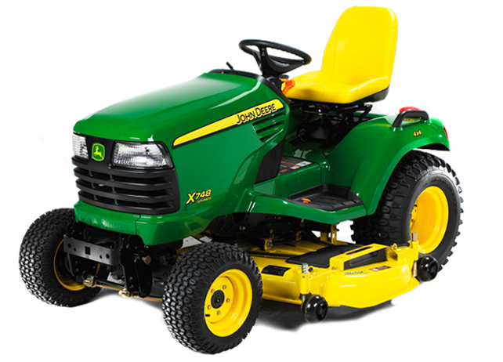 |  |  |  |  |  | Potential Hazards:  Exposed moving parts with the potential to cause harm through pinching, impact and crushing, ergonomics, vibration, noise, slips, trips and falls and dust.
Personal Protective Equipment (PPE) Required
  Gloves |  |   Face Masks |  |   Eye  Protection |   Welding Mask |  |   Appropriate  Footwear |  |   Hearing Protection |   Protective Clothing
Safe Work Procedure Checklist:
1. PRE-Operation:
- Check for obvious faults and defects including fuel leaks or damage.
- Identify ON/OFF key switch.
- Wear adequate and appropriate PPE.
2. Operation:
- Keep discharge chute down.
- Always be looking ahead for obstacles.
- Watch for trees, buildings, overhangs and other obstructions. Allow enough room to safely pass between obstructions. Be careful not to get too close.
- Check overhead clearance before passing beneath branches, awnings and other obstructions.
  - Keep hands and feet on unit.
  - Ensure firm footing.
  - Always keep eyes on direction of travel.
  - Do not have riders.
  - Do not allow people to approach when PTO is engaged.
  - Know the limits of the machine.
  - Keep unit in two wheel drive and four wheel drive only when necessary.
  - Use smooth operation on controls.
  - Engage PTO at low throttle.
3. POST-Operation:
- Ensure no damage has been made to unit or fluid leaks
- Ensure unit is parked on flat terrain and parking brake set.
- Ensure equipment is returned clean to storage area after use.
Competent Persons (The following persons are authorised to operate equipment.)
Date: | Name: |  |  |  |  |  |  | Trainer Signature:

Source: UI Healthcare Engineering Services
Date effective: September 20, 2016
Date Reviewed: September 20, 2016

