SUBJECT/TITLE: | Operating a Gas Powered Weed Trimmer
PURPOSE: | Safe Operation of a gas powered weed trimmer.

Policy Statement:

The Engineering Services Department will provide proper training to staff operating a gas powered weed trimmer.

Modification to Daily Attire Requirements: No exceptions will be allowed unless approved by the Director

Required PPE:
- Safety Shoes/ Boots with Reinforced Toe 5. Safety Glasses or Face Shield
- Appropriate Gloves as needed 6. Appropriate Clothing: Long Pants
- Hearing Protection, Ear Plugs, or Muffs 7. Dust Mask as needed
- Reflective Vest as needed

Required Training:

- Read, understand, and follow manufacturer’s safety instructions
- Training with qualified person prior to use

TASK | HAZARDS | CONTROLS
Preparing / Fueling Equipment | Skin or Eye Exposure to Fuel / Oils | Wear appropriate gloves for fuel
Preparing / Fueling Equipment | Skin or Eye Exposure to Fuel / Oils | Wear safety glasses
Preparing / Fueling Equipment | Fire | Never add fuel to hot or running equipment
Preparing / Fueling Equipment | Fire | Always add fuels outdoors, ensure fuel cap is secure before use of equipment
Preparing / Fueling Equipment | Fire | Do not add fuel near open flame, sparks or other ignition sources.
Preparing / Fueling Equipment | Fire | Clean fuel spills immediately; SPCC plan. Do not start engine until fumes have dispersed.
Operating Trimmer | Eye Injury | Wear safety glasses or full face shield to prevent injury from flying objects.
Operating Trimmer | Hearing Damage | Wear hearing protection: ear plugs or ear muffs.
Operating Trimmer | Bodily Injury: Cuts, Scrapes, Burns, etc. | Remain aware of your surroundings and be aware of changing conditions.
Operating Trimmer | Bodily Injury: Cuts, Scrapes, Burns, etc. | Watch for loose materials that can become airborne.
Operating Trimmer | Bodily Injury: Cuts, Scrapes, Burns, etc. | Maintain control of equipment at all times.
Operating Trimmer | Bodily Injury: Cuts, Scrapes, Burns, etc. | Keep hands and fingers away from moving parts.
Operating Trimmer | Bodily Injury: Cuts, Scrapes, Burns, etc. | Avoid contact with hot engine parts.
Operating Trimmer | Muscle Strain | Use proper ergonomics; maintain balance, avoid overreaching and twisting.
Operating Trimmer | Muscle Strain | Never bend and twist at the same time.
Operating Trimmer | Injury to Others | Use signs, cones, and barricades to warn others of work activities when in high traffic areas.
Operating Trimmer | Injury to Others | Maintain a reasonable safety zone from others - do not allow debris to fly towards pedestrians or vehicles.
Operating Trimmer | Injury to Others | Suspend use if heavy pedestrian traffic is present
Operating Trimmer | Injury to Others | Be aware of changing conditions.
Site Safety | Bodily Injury from Vehicles, Bicyclists, Etc. | Place signs, cones, barricades, caution tape, and lookouts as needed.
Site Safety | Bodily Injury from Vehicles, Bicyclists, Etc. | Wear reflective safety vests when in streets
Procedure for malfunctioning or broken equipment | Bodily Injury | Obtain tag and mark equipment "Do not use"- specify problem or hazard, date, name of writer.
Procedure for malfunctioning or broken equipment | Bodily Injury | Notify grounds supervisor immediately and take equipment to shop.
Training: Operation Of Gas Weed Trimmer

Training Video: https://www.youtube.com/watch?v=1Dt5C1vA5QA

DO NOT use this machine unless you have been trained in its safe use and operation. Training must be documented and signed by the employee before use.

Description of Work: |  |  | Operating A Gas Powered Weed Trimmer
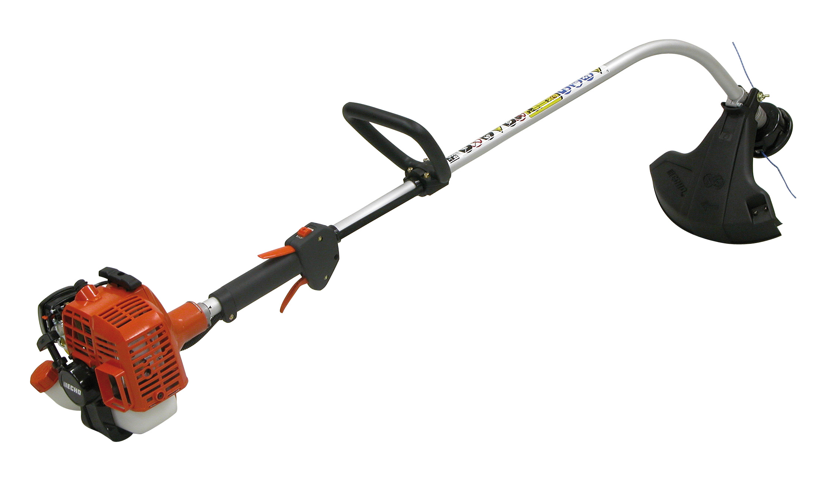 |  |  |  |  |  | Potential Hazards:  Potential to cause harm through flying debris, impact and abrasion, exhaust heat or crushing injuries, ergonomics, vibration, noise, slips, trips and falls and dust.
Personal Protective Equipment (PPE) Required
  Gloves |  |   Face Masks |  |   Eye  Protection |   Welding Mask |  |   Appropriate  Footwear |  |   Hearing Protection |   Protective Clothing
Safe Work Procedure Checklist:
1. PRE-Operation:
- Check for obvious faults and defects including fuel leaks or damage.
- Identify ON/OFF switch.
- Wear adequate and appropriate PPE.
2. Operation:
  - Exercise caution in relation to exhaust heat.
  - Hold trimmer firmly.
  - Ensure firm footing.
  - Move your body with the trimmer; do not twist from the waist.
  - Do not weed trim towards pedestrians. Move from right to left when cutting.

3. POST-Operation:
- Ensure weed trimmer engine have stopped before removing any debris under guard.
- Ensure engine has stopped before placing trimmer on the ground.
- Ensure equipment is returned to storage area after use.
Competent Persons (The following persons are authorised to operate equipment.
Date: | Name: |  |  |  |  |  |  | Trainer Signature:

Source: UI Healthcare Engineering Services
Date effective: July 7, 2016
Date Reviewed: August 3, 2016

