SUBJECT/TITLE: | Operating a Gas Powered Pressure Washer
PURPOSE: | Safe Operation of a gas powered washer.

Policy Statement:

The Engineering Services Department will provide proper training to staff operating a gas powered pressure washer.

Modification to Daily Attire Requirements: No exceptions will be allowed unless approved by the Director

Required PPE:
- Safety Shoes/ Boots with Reinforced Toe 4. Safety googles or face shield
- Appropriate gloves as needed 5. Long pants
- Hearing Protection, Ear Plugs, or Muffs

Required Training:

- Read, understand, and follow manufacturer’s safety instructions
- Training with qualified person prior to use

TASK | HAZARDS | CONTROLS
Preparing Pressure Washer for Use | Exposure to Fuel Mix: Skin & Eyes | Wear appropriate chemical resistant gloves and safety glasses or face shield.
Preparing Pressure Washer for Use | Fire/Explosion | Never fuel equipment indoors; keep fuel away from open flames or sparks
Preparing Pressure Washer for Use | Fire/Explosion | Clean up fuel spill immediately; do not start engine until fumes have dispersed.
Preparing Pressure Washer for Use | Fire/Explosion | Dispose of spilled fuel per SPCC Plan training: contain, label for disposal, and contact EHS
Operating Pressure Washer | Muscle Strain | Pull cord straight back; provide for clearance of arm and elbow.
Operating Pressure Washer | Muscle Strain | With wand use short, sweeping motions, avoid twisting and bending repetitively.
Operating Pressure Washer | Muscle Strain | Use safe lifting training-back injury prevention training.  Wear appropriate gloves to minimize vibration and fatigue on hands
Operating Pressure Washer | Hearing Damage | Wear earplugs or earmuff headset
Operating Pressure Washer | Inhalation of Dust/particulates by Self and or Others | Avoid creating excessive dust - pre-wet or wet area as needed.  Pause work to allow pedestrians-bicyclists or motorists to pass.
Operating Pressure Washer | Eye or Other injury to Self and or Others | Wear safety glasses or goggles.
Operating Pressure Washer | Eye or Other injury to Self and or Others | Pause work to allow pedestrians-bicyclists or motorists to pass. Never wash towards pedestrians!
Operating Pressure Washer | Eye or Other injury to Self and or Others | Set up safety cones or barricades, as needed, if work affects areas with pedestrian, etc.
Operating Pressure Washer | Insect bites | Wear long pants or equivalent protection
Operating Pressure Washer | Insect bites | Be aware of potential ground bees or yellow jacket nests.
Storage/transporting | Fire | Do not place hot equipment on or neat combustible materials or flammable liquids.
Storage/transporting | Fire | Allow engine to cool before storing - avoid contact with combustibles.
Storage/transporting | Fire | Store properly to prevent fluids leaking out of equipment.
Storage/transporting | Fire | Always secure equipment when in transit.
Procedure for malfunction or broken equipment | Bodily Injury | Obtain tag and mark equipment "Do not use" - specify problem or hazard, date, name of writer.
Procedure for malfunction or broken equipment | Bodily Injury | Notify grounds supervisor immediately and take equipment to shop.

Training: Operating A Gas Powered Pressure Washer

Training Video: http://www.mitm.com/support/videos/how-to-start-a-gas-pressure-washer/

DO NOT use this machine unless you have been trained in its safe use and operation. Training must be documented and signed by the employee before use.

Description of Work: |  |  | Operating A Gas Powered Pressure Washer
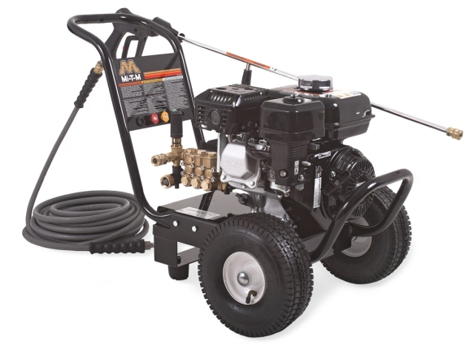 |  |  |  |  |  | Potential Hazards:  Potential to cause harm through forced water, impact and abrasion, exhaust heat or crushing injuries, ergonomics, vibration, noise, slips, trips and falls and dust.
Personal Protective Equipment (PPE) Required
  Gloves |  |   Face Masks |  |   Eye  Protection |   Welding Mask |  |   Appropriate  Footwear |  |   Hearing Protection |   Protective Clothing
Safe Work Procedure Checklist:
1. PRE-Operation:
- Check for obvious faults and defects including fuel leaks or damage.
- Identify ON/OFF switch.
- Wear adequate and appropriate PPE.
2. Operation:
  - Exercise caution in relation to exhaust heat.
  - Hold pressure wand firmly.
  - Ensure firm footing.
  - Move your body with the direction of work; do not twist from the waist.
  - Use trip hazard signs or cones.
  - Do not spray towards pedestrians or traffic.

3. POST-Operation:
- Ensure pressure washer engine has stopped and water off before releasing pressure on hose couplings.
- Ensure pressure hoses are drained of water and couplers hooked together and wand tips are placed back in holder.
- Ensure equipment is returned to storage area after use and full of fuel.
Competent Persons (The following persons are authorised to operate equipment.
Date: | Name: |  |  |  |  |  |  | Trainer Signature:

Source: UI Healthcare Engineering Services
Date effective: April 6, 2016
Date Reviewed: June 30, 2016

