SUBJECT/TITLE: | Operating a Kubota RTV
PURPOSE: | To facilitate safe operation of a Kubota RTV.

I. The Engineering Services Department will provide proper training to staff that operate any Kubota RTV Utility Vehicle.

II. Required PPE:
- Appropriate Gloves as needed 4. Safety Shoes/ Boots with Reinforced Toe
- Hard Hat as needed 5. High Visibility Vest as needed
- Safety Glasses as needed 6. Dust Mask as needed

III. Required Training:

- Read, understand, and follow manufacturer’s safety instructions.

- Training with qualified person prior to use.

TASK | HAZARDS | CONTROLS
Preparing Job Site And Equipment | Trips | Clear area within work zone; Remove trip hazards and/ or mark clearly hazards with cones, etc.
Preparing Job Site And Equipment | Cuts | Wear gloves when checking tires
Preparing Job Site And Equipment | Exposure to Oil/Coolant | Wear safety glasses and gloves if adding fluids
Preparing Job Site And Equipment | Bodily Injury to Others | Identify work zone with cones, barricades and other means necessary to keep pedestrian and other traffic out of the work zone
Operational Considerations | Bodily Injury | Wear proper PPE as needed for each assigned job duty
Operational Considerations | Bodily Injury | A pre-job discussion should occur to ensure both the equipment operator and assisting workers understand the scope of the project
Operational Considerations | Bodily Injury | Operator should keep watch for ground workers near equipment and ensure they are aware of operator's intended direction of movement. Use spotter as need to warn/watch for ground workers.
Operational Considerations | Bodily Injury | Ground workers should watch operator and equipment, staying clear of equipment's path
Operational Considerations | Bodily Injury | All workers need to be aware of changing conditions at work site area.
Equipment Operations | Falling Off Equipment | Fasten seatbelt properly as needed
Equipment Operations | Rollover | Do not drive recklessly
Equipment Operations | Rollover | Do not make hard fast turns
Equipment Operations | Rollover | Operate within manufacturer listed stability speeds
Equipment Operations | Rollover | Keep loads balanced and secured  Do not carry more than one passenger in protected cab
Equipment Operations | Bodily Injury to Operator | Never reach into areas with moving parts such as tires, hydraulics arms, and engine area while engaged
Equipment Operations | Bodily Injury to Operator | Never leave equipment running to clear tires or troubleshoot problems
Equipment Operations | Bodily Injury to Operator | Do not operate damaged or malfunctioning equipment
Equipment Operations | Bodily Injury to Operator | Be aware of changing conditions at worksite
Equipment Operations | Bodily Injury to Operator | Wear as needed PPE for each job accordingly
After operations or during periods when area is not occupied by workers | Bodily Injury to Workers and Others | Operator should leave bed in lowered position
 | Bodily Injury to Workers and Others | Operator should ensure equipment is secured by pulling the key and set parking brake
 | Bodily Injury to Workers and Others | Workers should secure job site with barricades, cones and signs to warn others to keep out of work site area.
 | Bodily Injury to Workers and Others | Supervisor may place employee to watch job site if extreme hazards exist.
Servicing or Repair of Equipment | Bodily Injury | Obtain tag from shop, mark equipment "Do Not Use"- Specify problem
Servicing or Repair of Equipment | Bodily Injury | Notify shop and/or take equipment to shop

Training: Operating A Kubota RTV Utility Vehicle

Training Video: https://www.youtube.com/watch?v=vTrYIap9KQo

DO NOT use this machine unless you have been trained in its safe use and operation. Training must be documented and signed by the employee before use.

Description of Work: |  |  | Operating A Kubota RTV Utility Vehicle
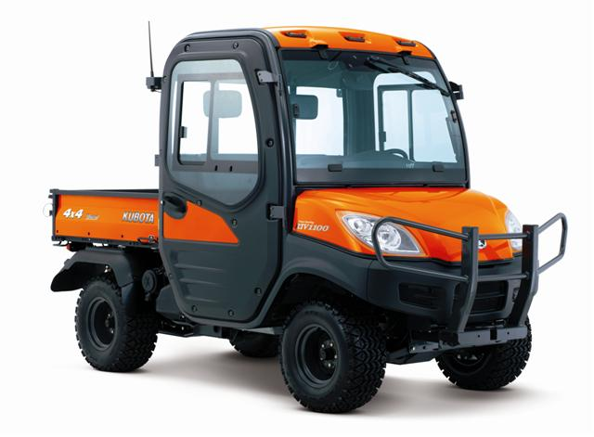 |  |  |  |  | Potential Hazards:  Exposed moving parts with the potential to cause harm through pinching, impact and crushing, shearing injuries, ergonomics, vibration, noise, slips, trips and falls and dust.
Personal Protective Equipment (PPE) Required
  Gloves |  |   Face Masks |  |   Eye  Protection |  |   Welding Mask |   Appropriate  Footwear |  |   Hearing Protection |   Protective Clothing
Safe Work Procedure Checklist:
1. PRE-Operation:
- Check for obvious faults and defects including fuel/hydraulic leaks or damage.
- Identify ON/OFF key switch and parking brake
- Wear adequate and appropriate PPE.
2. Operation:
- Use of seat belt as needed.
  - Keep hands and feet inside unit.
  - Adjust view mirrors accordingly.
  - Use both hands on steering controls.
  - Ensure firm footing.
  - Always keep eyes on direction of travel.
  - Use horn when approaching blind corners.
  - Do not have more than one passenger in cab.
  - Do not keep unit in four wheel drive: Unless needed.
  - Know the acceptable amount of load unit can safely handle and secure load as needed.
  - Keep bed in lowered position; always load/unload on flat terrain.
  - Use smooth operation when shifting and accelerating.
3. POST-Operation:
- Ensure no damage has been made to unit or fluid leaks.
- Ensure unit is parked on flat terrain and parking brake set.
- Ensure equipment is returned clean to storage area after use.
Competent Persons (The following persons are authorised to operate equipment.)
Date: | Name: |  |  |  |  |  |  | Trainer Signature:

Source: UI Healthcare Engineering Services
Date effective: July 1, 2016
Date Reviewed: July 1, 2016

